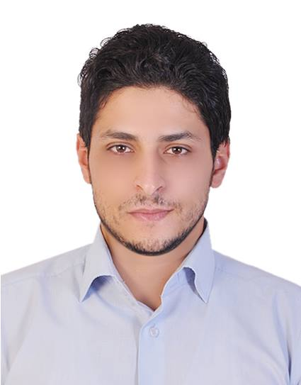

PROFILE

Highly skilled and knowledgeable Civil Engineer with a strong record of sound and safe public works construction projects. Adept at coordinating with building and engineering professionals for every project stage. Strong multitasked with exceptional skill in functioning well in a high-pressure work environment.

CAREER | PATH
Des 2014_ Feb 2016
Company: Darwish Engineering Company
Main Contractor.
Project Name: INDUSTRIAL AL SAJAA OSAIS. (Infrastructure & construction works)
Position: Site Engineer.
Location: ALSAJAA- SHARJAH
Owner: SHARJAH ASSET MANAGEMENT HOLDING
Consultant: Khatib &Alami Consultent
Project Value: 280 million dirham.

Responsibilities:

▪ Organize daily tasks of subcontractors and construction workers in accordance with weekly
Programs and supervise their work execution to ensure productivity and quality is achieved.
▪ Ensure quality of works in accordance with quality management plan and method statement.
▪ Ensure quality of works in accordance with quality management plan and method statement.
▪ Coordinate with MEP and subcontractors to obtain clearance on time.
▪ Full communication with all the government authorities and keep following all related
documents to clear all obstacles.

Company: Darwish Engineering Company Feb 2016_MAY 2017
Main Contractor.
Project Name: SHOMOUS PROPERTIES. (Infrastructure & construction works)
Position: Project Engineer.
Location: Sharjah
Owner: AL BATHA REAL ESTATE CO.
Consultant: EGEC Consulting.
Project Value: 63 million dirham.

Responsibilities:
▪ Organize and manage the actual work on site in order to meet programs and quality
standards.
▪ Coordinate specific technical aspects and focus on its interrelationships and appropriateness
to each discipline (Architectural, Civil, MEP works, Subcontractors and Specialty
Contractors).
▪ Review specification, drawings in order to resolve any discrepancies or conflicts. Also
following up RFI’s, shop drawing approvals, material submittals etc.
▪ Assist in monitoring cost control measures on labor cost, material movement, material use
and wastage in order to ensure productive work and continually reduce wastage.

Company: Darwish Engineering Company MAY 2017 – AT present
Main Contractor.
Project Name: SHOMOUS PROPERTIES.( construction works)
Position: Project Engineer.
Location: Sharjah
Owner: AL BATHA REAL ESTATE CO.
Consultant: CUBIC Consulting.
Project Value: 100 Million Dirham .

Responsibilities:
▪ General Managing for all the stuff and preparing all the requirements to be hand over to the
consultant stuff and keep connecting with sub-contractors.
▪ Full communication with all the government authorities and keep following all related
documents to clear all obstacles
▪ Following up each step from the project to be done according to time schedule.
▪ General supervision for all the shop drawings and execute it.

GVC Gruppo di Volontariato Civile Aug 2014 to Sep- 2014
Office engineer
- Emergency response for Palestinian families hosted in Gaza Strip'' as water Focal point

The Palestinian Ministry of Health Feb 2013- Jan-2014
Civil Engineer

- Following up with all ministerial project to make sure it is done in effective and efficient way
- Calculated cost and quantity estimates for public works projects
- Monitored automated computer design project implementations for accuracy and compliance with relevant regulations.
- Provided support as required for various development review procedures.

Internships

- As Site engineer
  - Future Bridge co(construction project) Jun 2012- July 2012
  - Darwish Abu Muaileq (Maintenance projects) July 2012- Sep 2012
  - Dawwas company(Infrastructure projects) Oct 2012- Nov 2012
  - Jawad Kuhail company (Maintenance projects). Dec 2012 – Feb 2013

KEY | SKILLS

Computer Skills
- Competent with most Microsoft Office Programs.
- Structural Analysis Programs, (Robot structural analysis, Prokon) .
- Drawing Program, (AutoCAD) .
- Planning and Scheduling Program, (MS Project) .
- Typing in both languages Arabic and English

Miscellaneous Skills
- Good human communication skills.
- The ability to work as a group.
- Detailed knowledge of construction principles and standards.
- Excellent paper work skills (reporting, documenting and archiving).
- Confident in handling new tasks.
- Self-motivated, and self-organized.
- Good understanding of safety.

ACADEMIC | QUALIFICATIONS

Islamic University Palestine. 2012
- B.Sc. in Civil Engineering - GPA 7.8/10

Khaled Bin Al-Waleed Secondary School, Gaza Strip. 2007
- General Examination Board (Average 89.4%).

Sharja Municipality Approval. 2017

Sharjah Electricity &Water Authority Approval 2018

TRANING | COURSES

- 24 hours in AutoCAD 2D, Infinity Center, Gaza.
- 30 hours in Robot Structural Analysis 2010, Infinity Center, Gaza.
- 21 hours in Advanced Excel, Continuing Education-Islamic University, Gaza.
- 30 hours in Geographical Information System (GIS), Al-Quds Company For Human Resources Development, Al-Nusseirat .
- 24 hours in professional Surveyor, Training Center, Engineers Syndicate, Gaza.
- 36 hours IELTS, Continuing Education-Islamic University, Gaza.
- 18 hours Pricing and Awarding construction Bids, small &medium Enterprise Business Training( SMET)

PERSONAL | DETAILS

Birth date : 12-04-1990
Driving License : Valid UAE Driving License
Marital status : married
Religion : Islam
Nationality : Palestinian
Languages : Arabic (native), English
Visa status : Employment visa

