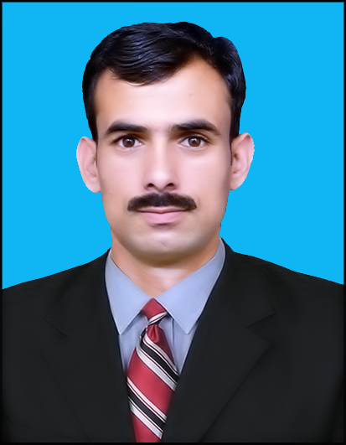
UMAR KHAN
Father Name AMANI MULK.
Date of Birth 10-05-1993.
Email umarkhan835214@gmail.com

Nationality Pakistani.
Address DUBAI (On visite)
CNIC.No 15603-0340904-9.
Passport No BQ4149041
Contact no 0527839176.
Marital status Single
Religion Islam.
Career Objective.

To gain as much practical knowledge as possible and to use my skills and abilities effectively . To utilize and enhance my capabilities, knowledge and skill in a viable manner for the benefit of the organization that encourages innovation and creativeness in the job process.

Education:

Session | Qualification |  | Obtained Mark s/Cgpa | %age-Division |  | Total Mrks/Cgpa |  | Board/University.
2008-2010 |  | SSC | 771 | 73% - A | 1050 |  | B.I.S.E Swat
2010-2012 |  | F.Sc | 724 | 65% - B | 1100 |  | B.I.S.E Swat
2012-2016 |  | Bsc Civil Engineering (4 Years) | CGPA (3.1) | 77% - A | C GPA (4) |  | Swedish College Of Engineering and Technology, Wah Cantt (Affiliated with U.E.T,Taxila)

Technical Skills.

- MS Word, MS Excel and MS PowerPoint with all aspects.
- Auto CAD.
- E-Tab.
- Installation, downloading and online registration of operating systems and other application software professionally.

Professional Experience.
- INTERNSHIP : Building works
- BRIDGE EXPERIENCE: DAWTOE BRIDGE in TERRA (KHEYBER AGENCY).
- Peshawar DHA (Defense Housing Authority) ROAD project .

Projects.
- Final Year Project: Strength And Cost Analysis Of Brick aggregate With Admixture.

Study Visits.
- Best Way Cement factory Hattar, Pakistan
- Metro Bus Project Rawalpindi, Pakistan
- Tarbela Power Station, Pakistan

Other Skills.

- Good in written, understanding and speaking Urdu, English and Pashtoo.
- Social and have good administration skills.
- Two months internship in the field of construction.

References.
- Will be furnished on demand.

