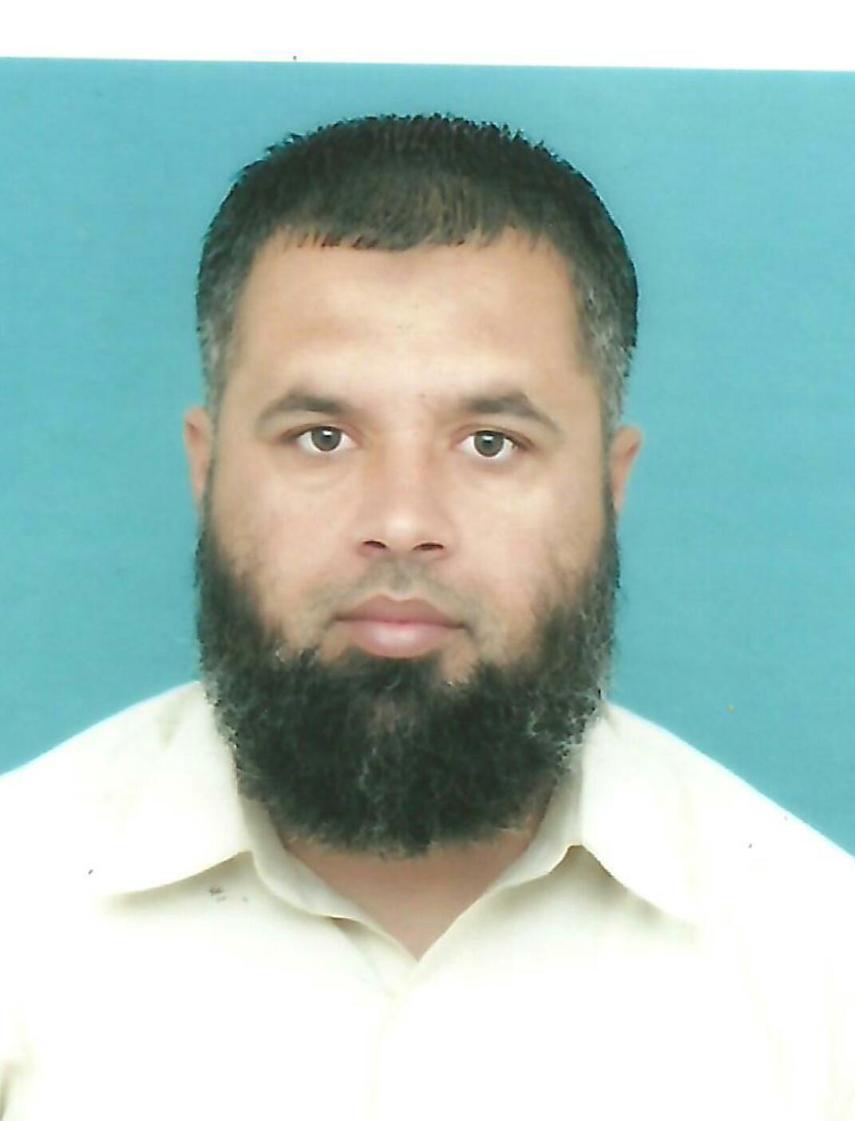
RESUME
QC MECHANICAL & WELDING INSPECTOR

ADEEL AHMAD
CSWIP3.1(Cert No.64113)
(ARAMCO APPROVED)
SAP #: 70012656

PERSONAL INFORMATION:

NAME: ADEEL AHMAD

DATE OF BIRTH: JUNE 17, 1982

NATIONALITY : PAKISTANI

E-MAIL: zarkon89@yahoo.com

MOBIL: PAK:0092-348-8199667

Have a valid driving license both Pakistan and Saudi Arabia.

TECHNICAL QUALIFICATION:

- CSWIP3.1 WELDING INSPECTOR COURSE, 22 FEB,2012 IN DAMMAM . CERT NO 64113
- AMIANTIT FIBREGLASS REINFORCED THERMOSETTING RESIN, PIPE SYSTEM,
HANDLING AND STORAGE APPLICATIONS.
- HEMPEL BASIC PAINT TECHNOLOGY WITH INTRODUCTION TO SAUDI ARAMCO
HEMPEL APCS SYSTEMS

SOFTWARE KNOWLEDGE:

- APPLICATION PACKAGES :MS-OFFICE

SPECIALIZED TRAINING / SEMINARS:

- CSWIP 3.1 WELDING INSPECTION COURSE DEC 22,2011, PAKISTAN
- HANDLING & ASSEMBLY OF RTR PIPE SYSTEM MAY 01,2008 .KSA, DAMMAM
- HEMPEL BASIC PAINT TECHNOLOGY TRAINING . KSA, DAMMAM

FAMILIAR WITH CODES:
- API -1104 FOR CROSS COUNTRY PIPELINE & REFINERY
- API -598 VALVE INSPECTION AND TESTING
- API -5L SPECIFICATION FOR LINE PIPE
- SAUDI ARAMCO ENGINEEREING STANDARDS
- ASME-B 31.4 FOR LIQUID PETROLEUM TRANSPORTATION PIPING SYSTEM
- ASME-B 31.8 FOR GAS TRANSMISSION & DISTRIBUTION PIPING SYSTEM
- ASME-SEC IX .WELDING & BRAZING QUALIFICATION

- Job Responsibilities:

- Prepare the RFI & checklists in accordance to approved Inspection test plan(ITP) prior to commence of work.Ensure that Quality Control activity is implemented per approved QCP, ITP and Project Standards and Specification.
- inspection and monitoring primary and secondary supports, guides and axial stopper installation and welding.
- Review and submit documents like WPS, Method Statement and Technical Queries, advise and recommends corrective actions if deficiencies were noted in meeting Project Specifications or Standards.
- Witness PQR and Mechanical Testing of Test Specimens by an approved Third Party NDT/NDE Company.
- Witness Welders Qualification Test in accordance with ASME IX & AWS D1.1).
- Monitor Sub-contractor’s inspector, communicate and coordinate with them to ensure that inspection activities are carried out in all stages of the work.
- Coordinate with client inspector with regards to quality issues and determine how to maintain/improve quality facilitate work progress.
- Prepare NCR/surveillance report, investigate root cause and propose preventive action to avoid violation from repeating.

- Inspection of Pipe Fabrication And Erection.
- Inspect And Monitor Primary And Secondary Supports, Guides And Axial Stopper Installation And Welding.
- Supervise Clearing Of Punch-List And Pipe Modifications As Required By Punch List.
- Generate Production And Accomplishment Report.
- Check Material Take-Off And Dimensions.
- Check Material As Per Construction/Fabrication Specification And Standard.
- Fit Up, Welding Inspection And Final Inspection For
cs, P11 Etc. Low And High Alloy Steels, Ss 316, 316L duplex and super duplex Etc.
Equipment Related Piping Including Equipment Internal Piping Inspection
With Respect To Internal And External Alignment, Root Gap Bevel Angel, Groove Angle As Per Approved Drawings , Applicable Wps, Project Specifications.
- Review and submit documents like WPS, Method Statement and Technical Queries, advise and recommends corrective actions if deficiencies were noted in meeting Project Specifications or Standards.
- Witness PQR and Mechanical Testing of Test Specimens by an approved Third Party NDT/NDE Company.
- Witness Welders Qualification Test in accordance with ASME IX & AWS D1.1).

- WORK EXPERIENCE:

COMPANY : Bonatti s.p.a
Project : SWRO (SADARA) Kingdom of Saudi arabia (Al Jubail) Position : Welding and Mechanical / piping Inspector
Duration : March 2015 to Sept 2015

COMPANY : Mellitah Oil & Gas BV,Libyan Branch
Project : Maintenance of pumping station from wafa oil field to mellitah Position : Welding and Mechanical / piping Inspector
Duration : Dec 2013 to August 2014

COMPANY : CONTRACTING AND TRADING CO,(C.A.T)
PROJECT : MAINTAIN POTENTION PROJECT,KHURAIS(VARIOUS WELL HEADS)
Position : Qa/Qc Welding Inspector
Duration : August 2012 To August 2013

COMPANY : CONTRACTING AND TRADING CO,(C.A.T)
PROJECT : UBTG-1 PIPELINE REPLACEMENT . (BI #: 10-001066)
Position : Qa/Qc Welding Inspector
Duration : June,2012 To Sep 2013

COMPANY : CONTRACTING AND TRADING CO,(C.A.T)
PROJECT : UBTG-1 PIPELINE REPLACEMENT . (BI #: 10-001066)
Position : Qa/Qc Mechanical Inspector
Duration : Feb, 2011 To july, 2012

COMPANY : CONTRACTING & TRADING CO,(C.A.T)
PROJECT : SAUDI ARAMCO PROJECT – MGS:SRG-2 PIPELINE PCV & METER STATION UPGRADE . B.I # : 10-00433
Position : Qa/Qc Mechanical / Piping Inspector
Duration : Nov,2009 To Feb,2011

COMPANY : CONTRACTING AND TRADING COMPANY (C.A.T)
PROJECT :MARAFIQ SALES GAS SYSTEM TO IWPP (JUBIAL)
Position :Qc Mechanical Inspector / Piping
Duration : January 2009 To July 2009

