##### *CURRICULUM*

##### *ITAE*

**MUHAMMAD WASEEM**

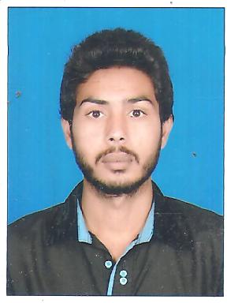



**Address:** House # 59/D Sadiq Town Rahim Yar Khan

**Cell #:** +923047573094

# OBJECTIVE

If I am selected for this post I try my best to full fill entire satisfaction of my seniors Insh Allah.

# PERSONAL INFORMATION

# Father's Name Muhammad Shabbir

# Date of birth 05-06-1995

* CNIC 31303-3078133-9
* PASSPOST NO. CS6851331
* Gender Male

# Domicile Rahim Yar Khan (Punjab)

# Nationality Pakistani

# Religion Islam

# Marital Status Un-Married

* Email Mavraali4@gmail.com

# ACADEMIC QUALIFICATION

|  |  |  |  |
| --- | --- | --- | --- |
| **Degree** | **Marks** | **Year** | **Board/University** |
| Diploma (Civil) 3 years | 2525/3500  A Grade | 2015 | PBTE LAHORE |
| Auto Cade (2D+3D) | A Grade | 2012 | ELEGANT EDUCATION SYSTEM |
| Civil Draftsman (1 Year) | A Grade | 2017 | Govt TTI College Rahim Yar Khan |
| Computer literacy program (6 Month) | A+ Grade | 2013 | Electromen’s Institute of I.T and Computer |
|  |  |  |  | |

# EXPERIENCE

* July-2015 to August-2016 “Surveyor” B@Q Construction Company
* September-2016 to Till “Surveyor” CSCEC China State Company

(CSCEC Peshawar to Karachi Motorway CPECK Section 2)

# SKILLS/ ABILITIES/ KNOWLEDGE

* GPS
* Auto Level
* Total Station
* Auto CAD 2D+3D
* Drafting
* Structure
* Quantity
* MS EXCEL
* Layout

# LANGUAGE

* Urdu: Have Good Command and Using Urdu Language
* English: Speaking and Understand Well.

# REFERENCE

* Reference will be furnished on Demand.