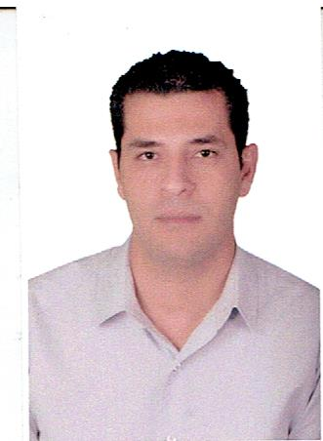
Ahmed Said Ahmed Salem
Safety Officer
E-mail: ahmed.said2@hotmail.com
Tel: 00971556361812
Objective
- My goal is to become associated with a company where I can utilize my skills and gain further experience while enhancing the company’s productivity and reputation.
Personal INFORMATION
- Nationality : Egyptian
- Date of Birth : 18/09/1982
- Marital Status : Married
- Religion : Muslim
- Visa Status : Resident
Educational
- Bachelor Social Work (2008)
Experience

- Safety Officer in Five Star general contracting company in Abu Dhabi-from December 2015.UntilNow
*Projects:
- TAWASUL TAXI BASE PROJECT ( Mussafah – Abu Dhabi )
- Nasser Salem Humaid Al Dhahak Al Mansory Building ( Bani Yas – Abu Dhabi )
- Safety officer in El Aqsa construction company in Cairo - Egypt from March 2011 to October 2015
*Projects:
- Cement Silo in ZUEZ Cement factory in ( Cairo – Egypt )
- Pitcho American City in ( Cairo - Egypt )
- Youth city (15 May- Helwan - Cairo)
- Laboratory technician in Tourah cement company in Egypt from February 2009 to January 2011
Certifications
- NEBOSH certificate for IGC1
- IOSH managing safely – IOSH United kingdom
- OSHA General Industry – OSHA Academy USA
- OSHA Construction – OSHA Academy USA
- Scaffolding inspector – Orient Management Consulting &Training
- Basic Occupational safety and health (safety specialist) at NOSH – National of occupational safety and health in Egypt.
- waiting for NEBOSH certificate for (IGC2&IGC3)
Responsibilities
- Prevent accidents, injuries and work-related diseases in the workplace.
- Use their knowledge and skills to promote a positive health and safety culture in the workplace.
- The employee health and safety and creating a document regularly updated to reflect any changes to the law. It is the responsibility to ensure that every member of staff is aware of and committed to this policy.
- Regular inspections and risk assessment, and to ensure that any hazards or defects have been corrected on the spot. It also will keep the book incidents must be recorded and thorough investigation of any accident, and recommend any improvements in safety standards if necessary.
- Responsible for ensuring that employers and workers comply with safety legislation and that safety policies and practices are adopted.
- Health and safety officers are based in a wide range of organizations, from multinationals to small consultancies, and help to plan, implement, monitor and review protective and preventative safety measures.
- Training for all staff in safety issues, and advising them on the clothes and equipment as protective. They also act as a main point of contact for any member of staff who has a question or concern about the safety of the workplace.
- Duties of the health and safety officer and include the protection of machinery and fire safety, occupational health, noise, and control of hazardous substances, manual handling, working with display screen equipment.
Computer proficiency
- Word, excel, power point, access.
- Very Good Knowledge of outlook and internet
Language
- Fluent in Arabic (speaking and writing)
- Good in English (speaking and writing)
SKILLS
- Hands-on, Driven, Entrepreneurial
- Able to attract, recruit, lead and manage top performers
- Ability to develop people
- Persistent, Proactive & quick to understand and absorb new information
- Aggressive & Enthusiastic, “can do” attitude
- Strong work ethic
- Good organizational and administration skills
- Positive attitude and good communication skills
- Commitment to delivering a high level of customer service
- Confident telephone manner
- High level of IT skills
- Excellent grooming standards
- Demonstrated previous experience working in a Sales environment
- Knowledge of the hotel property management systems
- Demonstrated previous experience working in the Conference & Events function
- Qualification, degree, or certification in a relevant field
- Arabic language

driving license
- Egyptian driving license

