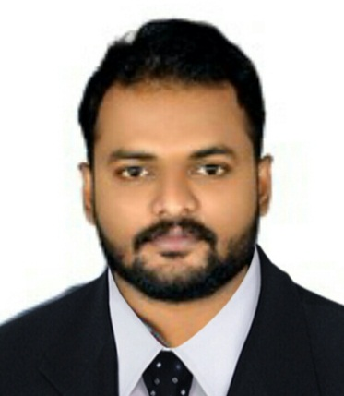  Personal Information  RENDHEER.ER  Room No: 402  Hassan Al Bahri  Near Ministry of Labour  Al Qusais, Dubai, UAE  Mob: 0581486056  Dateof Birth: 24-05-1992  Father: Ravidran.E G  Sex:Male  Nationality: Indian  VISA STATUS :  VISIT VISA  VISA EXPIRY DATE:  22nd May, 2018  Marital Status: Single  Languages Known:  English , Malayalam, Hindi &Tamil  E-mail:  rendheer.er@gmail.com  PermanentAddress:  Edathara {H}  Padukad  Viyyur p.o  Thrissur - 680010  Kerala | CURRICULUM VITAE  CAREER OBJECTIVE  Seeking a suitable position to utilize my skills and abilities that offers ample scope for personal & professional progression, to contribute towards the quantitative and qualitative enhancement of the organization.  STRENGTHS  Fast learner, Focused & Achievement Oriented.  - Self-motivated, with good inter personal and communication skills.  - Hardworking & Dedication to achieve Company’s Objectives.  - To achieve the goals through patience, consistency hard work & honesty.  - To apply & integrate the knowledge and skills learned.  EDUCATIONAL PROFILE  Qualification Institution Board / University Year of Passing Marks Scored  B.E CIVIL ENGINEERING Hindusthan College of Engineering Anna University Chennai 2014 60%  Plus Two SanthaHigher Secondary School Avanoor Kerala Government of Kerala 2010 60%  S.S.L.C Model Boys HSS Thrissur Government of Kerala 2008 75%
EXPERIENCE

- 3 years experience in Aspire Home construction as Site Engineer(Sub Contract Work)

• Responsible for Site Execution and Supervision for the construction of villas
• Role of main technical advisor on construction site.
• Execute the work as per drawings and specifications.

KNOWLEDGE & SKILLS
Working Knowledge

AutoCAD (All Version)
Autodesk 3DS Max
Adobe Photoshop
Microsoft Office Excel & Word
Microsoft Windows

SUMMARY

My greatest wish is to lead a career that will continuously provide me opportunities to study new technologies, which will make me stretch my own capabilities resulting in both the organization and personal satisfaction and growth. I want to apply the knowledge that I have gained to realistically improve and guide the future of the organization.

DECLARATION

I hereby declare that all the details furnished above are true to the best of my knowledge and belief.

RENDHEER.ER
Place : Dubai
Date : 26/02/2018

s

