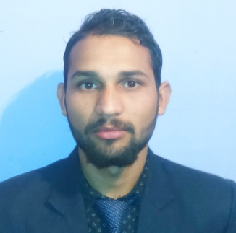
HARISH CHANDRA

37, MINI MIG MDDA COLONY
DALANWALA DEHRA DUN
UTTARAKHAND, 248001
mukkyrawat5@gmail.com
Mob No: 9639196682

Professional Profile
Think Positive, Hard Working and to Achieve my Goals in a very efficient manner.

Objective
Seeking an opportunity to work with a reputable company that will enable me utilize my skills for the benefit of the company.

Skills
          - Basic knowledge of Computer. (Internet, Outlook Express, Excel, Word.)
          - Functional Knowledge of AUTO CADD 2D
          - knowledge of Aggregate & soil test, Workability Cube test.
.

Relevant Work Experience
Summer 2016  2015-2016  2017 |  | BHARAT CONSTRUCTION PVT. LTD.  - One Year experience in Protection work on chronic land slide zone on Khairna Ranikhet road under the P.W.D. (A.D.B.) Nainital..  TRENING AT P.W.D.  - Certification and training done as Site Engineer At P.W.D Ghansali (Tehri Garhwal).  - Five month worked in Power Project ‘DAM’ in Shrinagar Uttarakhand As a Suparvisor.  NON GOV. ORGNIGETION (N.G.O.)  Shri Kalinka Vidhya Mandir Samiti Ghansali Tehri Garhwal, Uttarakhand.  Himalai Gyan Vigayn Sansthan Ghansali Tehri Garhwal, Uttarakhand.  six month working in BAF India Pvt. Ltd. Company Delhi In N.O.C. Department.

Education
2015 |  | Diploma in civil Engineering  UBTER
2011  2008 |  | Intermediate (12th)  12th Passed from U.K. Board With 60%.  HIGHSCHOOL (10th)  10th Passed from U.K. Board with 62%.
Declaration
Hereby declare that the above information are true and correct to the
Best of my Knowledge and no part of it is false.

Leadership Activities and Awards
2012 |  | Uttinciduntvolutpaturna. Mauriseleifendnullaegetmauris.
2010 – 2012 |  | Sedcursus quam id felis. Curabiturposuere quam velnibh.
2010 – 2011 |  | Crasdapibusdapibusnisl. Vestibulumquis dolor a felisconguevehicula.
2010 – 2011 |  | Maecenas pedepurus, tristique ac, tempus eget, egestasquis, mauris.
2009 – 2010 |  | Curabitur non eros. Nullamhendreritbibendumjusto. Fusceiaculis, estquislaciniapretium, pedemetusmolestie lacus, at gravidawisi ante at libero.

Professional Affiliation
2011 – Present |  | National Center of Public Health New York
2011 – Present |  | Community of Health Volunteers New York

Copyright information - Please read

© This Free Resume Template is the copyright of Hloom.com. You can download and modify this template for your own personal use to create a resume for yourself, or for someone else. You can (and should!) remove this copyright notice (click here to see how) before sending your resume to potential employers.

You may not distribute or resell this template, or its derivatives, and you may not make it available on other websites without our prior permission. All sharing of this template must be done using a link to http://www.hloom.com/resumes/. For any questions relating to the use of this template please email us - info@hloom.com

