MALIK JARAR HAIDER

PROFESSIONAL SUMMARY
Experienced IT and CCTV Installer with knowledge of all sorts of security system installation needs. Extensive knowledge of multiple security systems. Has eight years of industry experience in installation of CCTV and maintenance of installed systems.
PERSONAL INFORMATION

Father’s Name | : Muhammad Safdar Awan (late) | 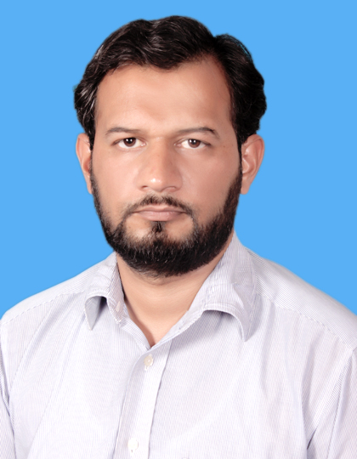
Date of Birth | : Jan 07, 1984
Nationality | : Pakistani
Passport # | : AL6972702
N. I. C # | : 37201-1746270-5
Domicile | : Chakwal Punjab
Marital Status | : Married
Permanent Address | : House no#18/595 MCB Mohallah Farooqi Jhelum Road Chakwal  District, Chakwal.  (Pakistan)
Cell #  Whatapp number  E-Mail | : +92 3142195074  : +92 3142195074  : Jarar.haider@yahoo.com
ACADEMIC QUALIFICATION
B TECH ;-
  - Bachelor of Technology in Electronics Engineer from Preston university camp Islamabad
(Pakistan) Year 2005-2007

D A E :-
  - Three-Year Diploma of Associate Engineer in Computer Technology from Wah Swedish Institute of Technology Wah Cantt
(Pakistan) Year 2001-2004
MATRICULATION (SSC):-
- Government Higher School No-1 Chakwal (Pakistan)

PROFESSIONAL CERTIFICATION/AWARDS
- A+ and Networking from National institutes of science Technology Islamabad.
- Computer Basic Application form Wah informatics of technology wah cantt.
- CCNA Course from TNA institutes from sub Camp Texila University.
- 8 YEARS PROFESSIONAL EXPERIENCE IN THE FOLLOWING
DEFENCE HOUSING AUTHORITY RAWALPINDI- ISLAMABAD
POSITION | TECHNICAL SECURITY OFFICER
DURATION | Since 15 March 2018 to continues
PROJECT | - DHA PHASE 1 and PHASE 2 project
DEPARTMENT | TECHNICIAL DEPARTMENT
RESPONSIBILITIES | - Installing and maintaining CCTV systems (Cabling, drilling, conducting, camera fixing, connector crimping.  - Wireless cameras installation via Neno Station and Bridges.  - Installation of Analog and IP System Cameras  - Installation & Program DVR / NVR and other Recording unit.  - Dress and route cable into closets and control rooms  - Additional duties include monitoring. Equipment, preparing purchasing requests for materials needed for each project and writing daily and monthly reports regarding maintenance work provided.  - Experience troubleshooting, assembling, disassembling.  - Installed CCTV systems in Commercial settings, including parking lots, inside stores and over registers as requested and needed  - Made recommendations regarding where cameras should be installed according to individual building's construction  - Performed residential installations of CCTV security systems.  - Tested all installations and setups to make sure they worked.  - Used own tools and truck to complete CCTV installations.  - Design and installation of Structure cable.  - Design and installation of Telecommunication infrastructure.  - Testing and communicating quality procedure.  - Cable management system with trouble shooting.  - Infrastructure for computer Network and Wireless Network system  - Data Network infrastructure.  - Make Connecter with Color coding RJ-45  - Installation of Cat, 6 Cat, 5 UTP and STP installation.  - UTP and STP Connecter termination.  - Tested the CCTV, security and the fire alarm functions with the help of the testing equipment’s, fixed if any malfunctions.  - Barrier Gate via PLC and replay, sensor solve problem.  - Walk through gate solve problem.
NAMA INTERNATIONAL TECHNICAL SOLUTION MUSCAT
POSITION | IT AND CCTV TECHNICIANS
DURATION | 10 June 2016 to 20 Jan 2018
PROJECT | - Wood factory sohar  - sohar Aluminum Company  - Oman chamber of commerce and industry Muscat  - Muscat,Sohar construction site project
DEPARTMENT | TECHNICIAL DEPATRMENT
RSPONSIBILITIES | - Installation of outdoor CISCO Wi-Fi Devices.  - All outlook (2010, 2013 and 2016) email configures and Email data backup restore.  - All windows (window 7,8,10) installation 8,1 like as client and window server installation  - Outdoor Cat 6 installation and PVC Piping and Duct Cabling  - Labeling of data cable  - Pulling and dressing of data cables  - CCTV Cameras installation Analog and IP  - UTP and STP Connecter termination  - Optical Fiber Splicing and Testing.  - Site survey to identify the fiber cable path & get the costumer approved  - Installation & Program DVR / NVR and other Recording unit  - Tool using OTDR, Splicing Machine, VFL, and Power meter.  - Biometric installation and config….  - Security alarm Worked on a team that did the installation for large commercial buildings.
TRAVEL SOLUTION PVT LIMITED KARACHI AND BRANCH KHARIAN
POSITION | TECHNICAL SUPPORT EXECUTIVE
DURATION | Dec 2011 to May 2016
Department | TECHNICIAL DEPARTMENT
RESPONSIBILITIES | - Set up workstations with computers and necessary peripheral devices (routers, printers etc.)  - Check computer hardware (HDD, mouse, keyboards etc.) to ensure functionality  - Install and configure appropriate software and functions according to specifications  - Develop and maintain local networks in ways that optimize performance  - Ensure security and privacy of networks and computer systems  - Provide orientation and guidance to users on how to operate new software and computer equipment  - Organize and schedule upgrades and maintenance without deterring others from completing their work  - Perform troubleshooting to diagnose and resolve problems (repair or replace parts, debugging etc.)  - Maintain records/logs of repairs and fixes and maintenance schedule  - Identify computer or network equipment shortages and place orders  - Laser printer Technicians diagnose, troubleshooting and solve printer issues.  - They commonly provide support within specific offices.  - Electricians install, maintain and repair electrical power for connection.  - Managed and configured cisco 2600 series routers and cisco 2900 switches.  - Have a excellent knowledge of SQL, PHP.

SUMMARY OF SKILLS | - Networking  - Troubleshooting  - OTDR Testing  - OFC Splicing  - OFC Design

COMPUTER SKILLS | - Ms Office (WORD, EXCEL, POWERPOINT)  - Operating Systems (WINDOWS XP PROFESSIONAL, WINDOWS 2000 PROFESSIONAL, WINDOWS 98 SE, WINDOWS 7 ULTIMATE, WINDOW SERVER)  - Internet Using  - Hardware Maintenance  - e Mail Handling  - Out Look  - Software Installation

LANGUAGES | - English  - Urdu  - Punjabi

____________________________________________________________________

