VINAYAKRISHNAN. T
: 00971-589487540 UAE
: vinayankalliot@gmail.com
: Alungal Nivas Kalliot Kanhiradukkom, P.O, Kasargod Dist.-671531, Kerala, India

Seeking assignments as Senior Land Surveyor in Civil/ Electrical/ Oil Sector, preferably in GCC
SUMMARY
Over 13 years of experience in Surveys, Coordination & Team Management with well-known organisations in Civil, Electrical, Oil & Gas, Refinery and PetrochemicalProjects across Middle-East. Well versed with all survey work related to construction of buildings and infrastructure. In-depth knowledge of modern survey principles, methods, techniques and instruments as well as rules and regulations related to land survey. Exposure in carrying out surveyof Road, Overhead Lines, Tunnel, Buildings& Utilities.

Well versed with AutoCAD and Draughting Techniques and proficient at conducting field surveys with modern survey equipment’s, vise GPS, Total Station. Proficient in organising and maintaining accurate records of survey data, etc. Strong relationship management, communication skills with the ability to network with project members, consultants, contractors with consummate ease. An energetic leader with excellent skills in managing a professionally and culturally diverse group of people

CORE COMPETENCIES
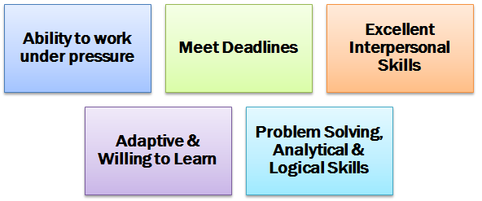 | 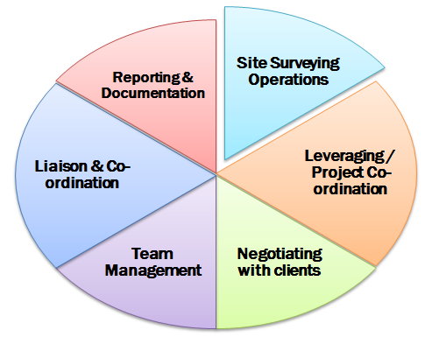

Civil Survey: Coordinating in overall administration and project execution plans including scheduling of Project, Profit and loss analysis, monthly budgeting, monitoring as per master plan, project closing, analysis of bought out materials, etc. Analysing subcontractors’ terms and conditions for various risks such as ambiguities, conflicts or deviations from the scope of work. Appraising the value of proposed constructions or other structures and preparing the valuation of progress and final payments in connection with any contract or sub-contract.

Land Survey: Overseeing and certifying land surveys. Rendering services such as mapping and related data accumulation, construction of layout surveys, precision measurements of length, angle, elevation, area and volume, as well as horizontal and vertical control surveys, and the analysis and utilization of land survey data. Managing the maintenance of survey party vehicles, tools, and equipment and approving legal descriptions for land acquisition to ensure completeness and accuracy.

Coordination: Assisting administrative, professional and technical employees involved in conducting land surveys. Consulting with client departments to determine needs, recommend the most effective ways to provide services. Networking with consultants, contractors, clients to ascertain technical specifications as per prevalent rules.

ORGANIZATIONAL EXPERIENCE
May 2017 – may 2018 : Chandragiri Construction Company Kasargod Kerala India

Key Result Areas
- Conducting survey measurements using a variety of specialist technical equipmentlikeTotal Station, Digital Level, Laser Alignment Devices & Satellite Positioning Systems

Projects Handled
Project: WSS Chathanoor

Client : Kerala Water Authority
Scope : Conducting topographic survey and investigation work in chathanoor

PREVIOUS EXPERIENCE
Jan’14- Mar’ 17: Proger Engineering & Management, Riyadh, Saudi Arabia as Land Surveyor
Key Result Areas
Conducting survey inspections using a variety of specialist technical equipmentlikeTotal Station, Digital Level, &Satellite Positioning Systems
Monitoring and arranging surveying instruments for calibration and ensure all surveying activities are performed effectively, both topography and geodetic.

Projects Handled
Project: KAP 3
Client: Ministry of Interior
Tenure: Since Jan’14
Scope: The project includes construction of 620 security compounds consisting of 15 call centers, 199 police stations, 68 traffic stations, 54 roads patrol stations, 35 civil defense centers, 41 immigration departments centers, 33 drug addicts enforcement centers, 57 civil status administration buildings, 41 investigation and prosecution buildings, 12 border guard stations, 70 services and associated facilities in a various location across the Kingdom of Saudi Arabia
Instruments used: Leica Total station & Auto Level

Jun’11-Dec’13: Larsen & Toubro (Oman) LLC, Muscat, Oman as Civil Surveyor
Key Result Areas
- Conducting survey measurements using a variety of specialist technical equipmentlikeTotal Station, Digital Level, Laser Alignment Devices&Satellite Positioning Systems
- Establishing Road Formation Levels, setting O H L & Tower Points, underground utilities like electrical ducts, telephone/ water ducts
- Setting various Krebs like raised kerbs, flush kerbs, high kerb and drop kerbs
- Establishing co-ordinates and levels for major structures like tunnel, underpass, bridges and buildings
- Checking of:
  - Horizontal alignment of roads and structures as per the Contract drawing using Total Station having an accuracy of one second based on Global Position System (G.P.S)
  - Layout and levels of Abutment, piers for major &minor structures as per the contract drawings
  - cross-section drawings and quantities for Interim payment using Auto CAD
- Establishing reference Bench Mark by connecting G.T.S Bench Mark will be under taken using accepted survey practice of double run leveling conforming specified accuracy.
- Administering detailed topographic survey including all physical features of existing road, and the Terrain condition preparation of contour map

Projects Handled
Project: Power System Upgrade /132 KV Substations /OHL
Client: Petroleum Development Oman (PDO)
Tenure: Jun’12 – Dec’ 13
Scope: The project involved upgrading of 132 KV existing substations(2 Bays),Construction of new 132 KV substation-2 Nos, 68 KM of Overhead line(Twin ELM) using Concrete Poles and towers.
Highlights:
- Handled survey measurements using a variety of specialist technical equipment like Total Station, Digital Level, Laser Alignment Devices&Satellite Positioning Systems
- Analysed data using plans, maps, charts and computer applications such as Auto cad and other survey software
- Performed testing and calibration of survey equipment
- Established methods and procedures for survey field operations according to the quality procedure forth set for project requirement
- Monitored the work of professional staff by making and reviewing work assignments, establishing priorities, coordinating activities and resolving work related problems

Project: Construction of New 33 / 11 Kv 3x20 MVA Primary Substation & 33kv/11kv Cable at Azaiba North- 3
Client: Mott Macdonald & Company LLC
Tenure: Jun’11- May’12
Scope: Construction of new 33 kv substation-2Nos, 35 km of underground cable lines
Highlights
- Marking alignment for electrical utilities. Preparing all As Built Drawing in Auto Cad
- Verification of drawings for preparing survey data
- Resolve all survey conflicts during site execution
- Preparing survey report and coordinating with consultant for inspection
- Providing training and mentoring junior surveyors in the team
- Preparation of shop drawings and survey related drawings as per site condition
- Attained Safety Award in 2011
Instruments Used : Sokkia total station , Sokkia GPS & Auto level

.May’08-Mar’11: Yuksel Insaat Inc, Doha Qatar as Land Surveyor
Projects Handled
Project: Doha Express Way
Client: ASHGHAL
Tenure: Mar’10-Mar’11
Scope: The project involved construction of 7 km road , 4 nos of under pass and underground utilities
Highlights:
- Holds the merit of establishing and establishing Road Formation Levels
- Performed testing and calibration of survey equipment
- Assessed horizontal alignment of roads and structures as per the Contract Drawing using
- Established control points by Traversing using Total Station
- Checked cross-section drawings and quantities for Interim payment using Auto CAD

Project: New Doha International Airport (NDIA) Doha, Qatar
Client: Overseas Bechtel Inc, (OBI)
Tenure: May’08-Mar’10:
CP: 14- Airside/Landside Roadways & Bridges
Highlights:
- Accurately calculated and gave correction of closed traverse
- Provided levels for earth works (cutting and filling)
- Established:
  - Road corridors, alignments, road furniture, landscaping, etc.
  - Underground utilities including duct banks, culverts, chambers etc.
- Provided levels for the constriction of road structure in layers as sub-base, base &wearing course
- Carried out inspection of the verticality of high mast and street light poles
- Drafted RFI and Survey Reports appropriately as the project progress
- Effectively resolved all survey conflicts during site execution
Instruments Used: Trimble total Station , Trimble GPS & Auto level

Nov’07-May’08: Landec Engineers & Contractors, Cochin as Land Surveyor
Project: Topographic Survey of Seaport Airport Road Cochin India
Client: Roads & Bridges Corporation Govt. of Kerala India
Scope: Construction of 12 km road
Highlights: Led collection of Topographical Data, Cross-Sections and other survey data from site as per design requirement. Efficiently collated levels form site for preparation of contour maps. Performed detailed survey of road. Established control points by Traversing using Total Station

Jun’05-Oct’07: Jalanidhi Project (Govt. of Kerala), Kasargod as Surveyor
Project: Water Supply &Rain Water harvesting
Client: KRWSA (Kerala Water Supply & Sanitation Agency)
Highlights: Conducted detailed survey of pipe line route and prepared AutoCAD drawing. Establishedpoints for pipe line route

EDUCATION
2004 Survey (NCVT)-Industrial Training Dept. Govt. of India
2004 Certificate in Surveying from Kerala State Government
2004 Total Station Training (Landec Engineers & Contractors, Cochin

PERSONAL DETAILS
Date of Birth: 13th March, 1985
Passport No.: J6851181
Linguistic Abilities: English, Hindi & Malayalam
Driving License: GCC
Visa Status: Visit

