Dear Sir,
With this letter and CV, I would like to offer myself for a position with your company in Site Engineer or quantity controller that fully utilizes my proffessional and personal abilities.
I am searching for an opportunity to offer growth and advancement based upon individual merit and capability. My background reflects extensive successful experience within consultants and main contractors, I would like to utilize that experience in a position that will also allow me to use my communication and technical skills to secure new bussiness and maintaian existing customers.
As the civil Site Engineer of the company, my responsibilities included construction and maintenance work supervision, materials quantity surveying.
My CV is enclosed to provide you with details of my skills and accomplishments, I would love an opportunity to meet with you elaborate on how I can substantial contribution to your company’s profitability.
Thank you for your time and consideration. I look forward to speaking with you soon.

Sincerely,
JAICO C JOHNY

CURRICULUM VITAE
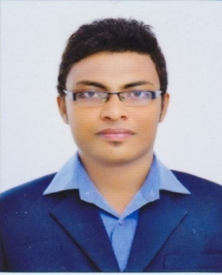
Name : JAICO C JOHNY
Contact no. : +91 8089565339
+974-55654194
Email ID : jaicocj5@gmail.com

OBJECTIVE
To productively apply educational experiences in a challenging environment contributing to the Organization, as this rapidly increases my technical and interpersonal skills & build strong team environments and developing open communications.

QUALIFICATION:
- B.E in Civil Engineering

- AutoCad (Autodesk)

- IOSH in safety

- Master Diploma in BIM (Revit Architecture + Revit Structure)

- Photoshop, Microsoft Office

- I have participation certificate of workshop & Autodesk

EXPERIENCES:

1+YEAR : JOS ALUKKAS BUILDERS & DEVELOPERS
THRISSUR, KERALA, INDIA,PIN:680001
(Imperial Towers at Kuttenellur ( Thrissur ),
Silver Square ( Thrissur),platinum city at
poochatti (Thrissur)) as Site Engineer.

6 Months : ASSET HOMES at guruvayur as Site Engineer.

1+YEAR : Working as Project Engineer under TDLCCS ( Thrissur
District Labour Contract Co-operative society.Ltd)
for the work of Kochi Metro Rail corporation under the
sub contract from Delhi Metro Rail corporation Ltd.
(DMRC)
PERSONAL INFORMATION:

- Nationality : Indian
- Email ID : jaicocj5@gmail.com
- Date of Birth : 19-10-1992

- Gender : Male

- Language Proficiency : English, Hindi,
Tamil & Malayalam

- Marital Status : Single

- PASSPORT DETAILS

- Passport No : M0198096

- Place of Issue : Thrissur

- Issue Date : 17-07-2014

- Expiry Date : 16-07-2024

- DECLARATION

I hereby declare that the above – mentioned information is correct up to my knowledge and I bear the responsibility for the correctness of the above- mentioned particulars.

Place: Thrissur JAICO C JOHNY

