Curriculum vitae

PERSONAL INFORMATION Hassan Mohamed Hassan Ibrahim

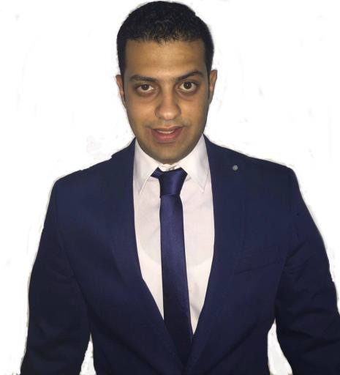 Silicon Oasis Building Lavista 2 , DUBAI, UAE 0562039343
enghassan159@gmail.com
https://www.facebook.com/hassan.mohamed.526

Sex Male | Date of birth 17 Aug 1993 | Nationality Egyptian

PERSONAL STATEMENT

WORK EXPERIENCE

Outgoing Certified Mechanical Engineering with +1 years of experience in Mechanical Construction Field. Seeking to leverage my technical and professional expertise to grow in a new role at your Successful company.

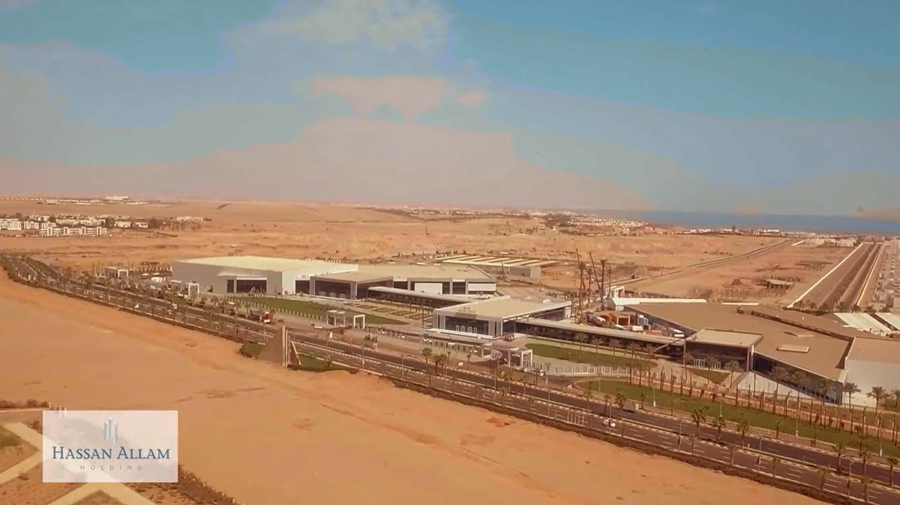1 JAN 2018– until now Mechanical Engineer as a technical office
AT : Hassan Allam Technology For Construction
Project : International Conference Hall SHARM SHEIKH

EDUCATION AND TRAINING

1999 – 2011

Oct 2011 – Jun 2016

Job Duties:
- Revise & Check Hvac,Fire Fighting Designs according to the related.
- submitting material for consultant approval, preparing BO, quantity surveying
- preparing shop drawing, revising shop drawing of sub contractors, & Material Selection 4- Monitor Mechanical activities based on the project schedule and advise project management.
- Design a chilled water network for a conference hall .
- coordination between all branches (electromechanical with architectural & structure) 7-Study and prepare requests for information (Rfi) for all missing, unclear, conflicting or other technical matters that may arise during construction.

Studied at Miami college language school (from junior to secondary)

The Arab Academy for Science, Technology and Maritime Transport Bachelor of Mechanical Power Engineer
Abu Qir ,AASTMT street, 21913 Alexandria (Egypt)
Major: Mechanical Power Engineering with Excellent with honours (GPA 3.86 ) http://www.aast.edu/ar/

Graduation Project
Combined steam generator cycle (power station)
Grade : Excellent with honours

Aug 2013–Sep 2015

July 2014 – Aug 2014

Alexandria fertilizers company
- In Gases production, Natural gas station and water treatment station.
-Headquarter and Plant. El Tabia, Rashid Road, Alexandria (EGYPT) www.alexfert.com/new

Middle East Oil Refinery (MIDOR)
perform the activity of crude oil refining and high-quality petroleum products processing, for domestic and international markets
-Amreya Free Zone, Alexandria Egypt www.midor.com.eg

Page 1 / 2

Aug 2015– Sep 2015 Oil and gas company
Courses
YEAR COURSE DESCRIPTION Place
2015 hydraulic and pneumatic Egyptian company for engineering training
2014 pumps operation , troubleshooting & maintenance oil and gas skills
2013 AUTOCAD & MATLAB academic
2012 Microsoft powerpoint & word academic

PERSONAL SKILLS
Mother tongue(s) Arabic

Foreign language(s)
English
 | Excellent command of Eglish language
Communication skills - Fast learner with many ideas , have the ability to find solutions to problems , with fast reaction.
- Excellent communicator that collaborates with team members and consults with third part vendors to achieve goals
- Work under pressure
- Implement a lot of tasks at same time
- Preparing high-quality written reports and presentations for management
- Always ready for new challenges
Organisational / mana  skills | gerial  - Leadership and good organizational skills.
- Diligent worker, Full of energy, Accuracy (precise) , organized and systematic
- Good team player
- Reliable and trustworthy person
Technical skills -High knowledge of the computer package MS Office ( Word, Powerpoint, Excel, Outlook) and
windows
- Knowledge of the use of the World Wide Web

- HAP
Driving licence B
ADDITIONAL INFORMATION
MARITAL STATUS Single
MILITARY STATUS Fulfilled in 1/3/2018

Page 2 / 2

