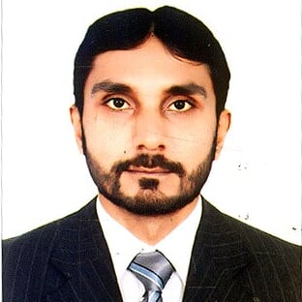

MUHAMMAD SHAKEEL
NEBOSH IGC, OHSAS 18001, Certified
Total Experience: 9 Year in Pakistan
HSE/Construction/Oil & Gas Experience: 9 years
Contact: +971 58 149 8547
Email: shakeel-malik@live.com
Address: Alfalah Street, Abu Dhabi.
Joining: Immediately

Visa Status: visit
Visa validity: 25 April 2018
Career Objective:
Seeking employment in the fields of Health & Safety in a dynamic organization. I am Expert at inspecting and evaluating workplaces for safety hazards and recommending and implementing safe workplace and procedures. Use my skills in a way to enhance the Health, safety and environmental impact of an organization with diligence and hard work.

Professional Work Experience:

Company: World Call Telecom Pvt Ltd (An Omantel Company) Pakistan.
Designation: Team Leader, Safety Officer,
Duration: 2007, December 2016
Job Description:
- Implementation of Company’s HSE management system. procedures, and project HSE Plan at excavation sites
- Conducting Tool Box Talks on regular basis on different HSE Topics, and maintaining the records.
- Implementation of Company’s HSE management system. procedures, and project HSE Plan at site
- Weekly meeting with managers about safety Issues.
- Provide HSE Training to working staff on different civil working sites.
- Scaffold inspection.
- Control of Substances Hazardous to Health (COSHH)
- To obtain weekly Safety Report from every Site Supervisor.
- Participate in Site HSE Meeting.
- Preparation of hazard identification and Risk Assessment and preventive actions.
- Ensure the compliance of Legal HSE requirements at workplace. .
- To promote HSE awareness among all the workforce at project through HSE trainings, HSE bulletins, handout and flyers etc.
- Coordinating with external Audit Team and follow up the deviations highlighted by Audit team for corrective actions.
- Communicate and advise to all staff and labors.
- Ensures that there is an adequate provision of emergency procedures, first-aid facilities, PPE.
- Incident Accident Investigation report and maintain record.
- Supervise all the excavation work for laying of metro network of fiber optic cables in the city.
- Monitors all the civil works on daily basis and carry out risk assessments.
- Coordinate with all the Client companies HSE staff members like Telenor Pakistan, Mobilink, Wateen Telecom, Multinet and Safe city project of Huawei Telecommunication international.

Company: Pakistan Oil Field Limited (POL) – Pakistan
Pindigheb, Attock Rawalpindi.
Designation: Trainee HSE officer
Duration: 1 year. 2013-14
Job Description:
- To develop, implement and monitor OSH Policy, Programs, and Procedures.
- Coordinate with the Rig Manager and Area QHSE involving QHSE concerns.
- To assist the HSE Manager in complying with current OSH legislation and regulations with the objective of ensuring that all reasonable and proper measures are taken to protect the safety and Health of personnel.
- Provide induction training to new employees, visitors and 3rd party personnel.
- Conducting Emergency Drills (H2S, Security, BOP, Fire, etc).
- Forming of H₂S, Fire Fighting and Rescue teams and training them.
- To increase health and safety awareness at all levels within the organization.
- To assist in investigation and report on all incidents/accidents.
- To investigate, report and suggest correct corrective measures on complaints of hazardous working conditions.
- To respond to employees’ safety concerns.
- To conduct HSE inspections (Environmental, Safety Harness, Camp Hygiene, Safety Equipment etc.)
- Responsible for records maintenance of HSE audits & inspections and follow up with respect to corrective actions.
- Facilitate in conducting different HSE meetings (Pre-shift, weekly, toolbox talks)
- Facilitate in implementation of STOP, PTW, LOTO and T-Cards systems.
- Responsible for effective execution of Rig Move Plan with the assistance of the Rig Manager.
- To coordinate registration and removal of hazardous waste.
- To arrange for OSH testing and evaluations of the workplace by client / external agencies / consultants as may be necessary.
- To act as liaison with all related governmental bodies and regulating agencies.
- To ensure up to date the training of personnel in areas of HSE including first aid, H₂S CPR, accident prevention, hazard hunts etc.
- To assist in preparation and implementation of emergency evacuation procedures.
- To liaison with the fire department regarding emergency procedures communications and fire safety education programs.
- Assist medic in provision of First Aid as necessary.
- To assume other duties as may be assigned.
- Developed and implemented corporate policies and other relevant documentation.
- Involved in designing & planning health care shows.
- Hosting morning show for a month which covered health information regarding food borne illnesses.
- Follow-up HR, Training and Certification Procedures.

Emergency Duties:
- Secure well in emergency situation.
- Assist in directing well kill operations.
- Direct crew in other emergencies such as fire fighting, H2S.
- Take initial steps to stabilize situation.

Professional Certification and Academic Qualifications

MASTER OF SCIENCE IN ECONOMICS. (2011-2013) (Preston University Kohat, Islamabad Campus, Pakistan)

BACHELOR IN COMMERCE. (Punjab University Lahore, Pakistan) (2004-2006)

NEBOSH-IGC (National Examination Board in Occupational Safety and Health) (2014)

OHSAS 18001:2007 (Safety Auditor Course) (2015) 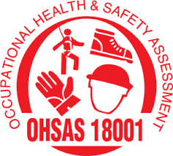
Rig Safety Certificate (Skill Development Council Pakistan) (2014)
H2S SAFETY Certificate (2014)

NASP FIRE EGRESS Certificate (2014) 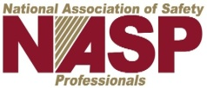
OSHA Certificate (Occupational Safety Health association) (2014) 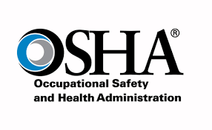 Fire Safety Certificate (2014) 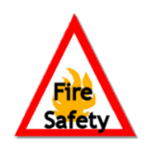

First Aid Certificate (2014) 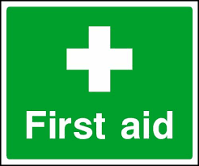

Trainings and Seminars

    - Industrial First Aid & Emergency Resuscitation
    - Principle of fire, fire prevention & control
    - Risk Assessment and Job Hazard Analysis
    - Occupational Health & Safety Management system ( BS OHSAS 18001:2007)
    - Rigging, Lifting, Banks men & Manual Handling
    - Basic Electrical Safety
    - Permit to Work, Accident Investigation and Reporting
    - Waste Management and Spill Control
    - Auditing and Reviewing.
    - Working on Heights, Fall Protection and Safety Harness Awareness
    - Control of Substances Hazardous to Health (COSHH)
    - Basic Know How of H2s gas and prevention.
    - Excavation safety measures.
    - Food Safety and Hygiene Certified

Personal Summary:
- Outstanding command over verbal and non-verbal communicative & interpersonal skills.
- Strong organizational, managerial, problem solving and negotiation skills.
- Quick and keen Learner, Loyal to my work.
- MS Office(esp. MS Word, MS Power Point and MS Excel)
- Languages( Urdu, Hindi, English, Punjabi)

References:
Made available on request.

