Mazen Mohamed Abd Elrahman
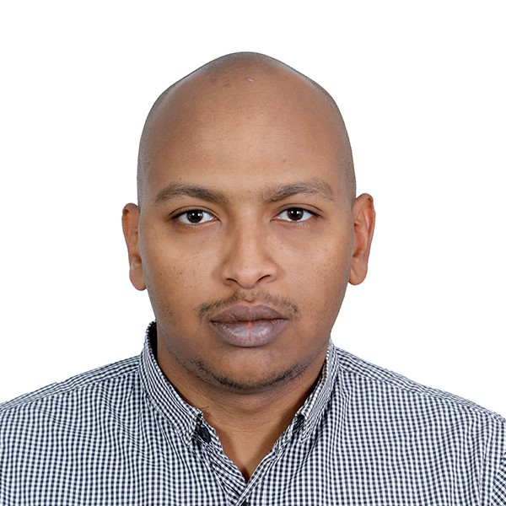
Phone : +971-56-1225086 / +971-52-6209330
E-Mail : ma2ziin10@gmail.com

Middle Level senior – civil engineer
Over 8 years’ rich, dynamic experience, with specialization procurement & estimation for many various projects (infrastructure ,roads contracting ,residential, commercial building& steel structure)
Targeting assignments for a long-term career as an engineer where I can demonstrate my technical, Management, leadership expertise and the ability of hard working to meet company objectives.
Location Preference: Dubai / Abu Dhabi

PROFILE SUMMARY

- I'm civil engineer work as procurement engineer for two years, as estimation engineer for more than two and half years in construction companies and for more than two years as a civil engineer in a consulting firm, as estimation engineer for more than two and half years in construction companies
- List of clients I have dealt with:
ADM~FEWA~ ZONESCORP~ GASCO ~ TAKREER ~ ADCO~ ESNAD ~ ADM~ ADSSC~ FGB~ ADCE
- Types of various projects:
Infrastructure ~ Sewerage network ~ Stormwater network ~ Steel structure~ Private buildings ~ Commercial buildings.

personal strength & SKILLS

~ Procurement, Vendor Development ~ Costing, Budgeting~ Liaison & Coordination.
~ Estimation Engineering ~ Client Relationship Management ~ Contractual Analysis, Tendering & Estimation.
~ Exceptional ability to manage multiple projects in a timely manner ~ Ability to work in a multi-culture environment.
~ Excellent to manage team works ~ Team player with proven leadership skills ~ Ability for working under pressure.
~Excellent communicator with strong written and verbal skills~ Dedication and commitment to achieving objectives.
~Quick learner and a hard-working person ~ Make sure that my work completed in a very Professional manner.

EDUCATION

- Dec 2004 – Oct 2009: BSc in Civil Engineering (construction) from Sudan University of science and technology
- (Excellent degree in graduation project).
- Course in AutoCAD.
- Course in Primavera.

Major projects handled

SL No. | Project Name | Client | Type of project | Position
1 | Additional infrastructure works in ICAD III | ZONESCORP | Infrastructure | Procurement engineer
2 | Norm handling, treatment, and disposal project at beaat | TAKREER | Infrastructure | Procurement engineer
3 | Building work RUMAITA/ SHANAYEL facilities phase III | GASCO | Infrastructure, steel structure and building | Procurement engineer
4 | Construction of permanent buildings for carbon black & delayed coker unit | GASCO | Infrastructure, steel structure and building | Procurement engineer /Estimation engineer
5 | Inter Refinery project -2 | TAKREER | Infrastructure, steel structure and building | Procurement engineer
6 | Internal Roads In Eastern Zone | MOPW | Infrastructure | Procurement engineer
7 | Four mosques of late Sheikh Zayed in Al-AIN | The Crown Prince Court | Building | Estimation engineer
8 | Renovation, repairing cracks and external paints of main building for ADCO in western region | ADCO | Maintenance | Estimation engineer
9 | Supply & Install of high flag at Gasco majlis premise - RHC (33M HEIGHT) | TAKREER | steel structure | Procurement engineer /Estimation engineer
10 | Commercial building of Dr, Ahmed Thani Almuhairi 12 stories in musafah | ADCE | Building | Civil engineer
11 | Fence for contractor’s laydown area at ruwais | GASCO | Fence | Procurement engineer /Estimation engineer
12 | Ruwais Refinery Expansion Project- Package#2 | GASCO | Building | Estimation engineer

WORK EXPERIENCE

Since Jan’2017 – Till Date: Deputed with Al Daman consultant office, Al Ain as projects manager
Responsibilities:
- Managing, supervising and visiting contractors on site and advising on civil engineering issues.
- Communicating and liaising effectively with colleagues and architects, subcontractors, contracting civil engineers, co-workers and clients.
- Managing change, as the client may change his or her mind on the design and identifying formalizing and notifying relevant parties of changes in the project.
- Leading teams of other engineers, perhaps from other organization or firms.
- Compiling, checking and approving reports.
- Reviewing and approving project drawings.
- Attending public meetings to discuss projects, especially in a senior role.
- Adopting all relevant requirements around issues such as building permits, environmental regulations, sanitary design, good manufacturing practices and safety on all work assignments.
- Ensuring that a project runs smoothly and the structure is completed on time and within specification.
- Correcting any project deficiencies that affect production, quality, and safety requirements prior to final evaluation and project reviews.
- Undertaking technical and feasibility studies and site investigations.
- Developing detailed design.

Since Jun’2015 – Dec’2016: Spark building contracting, Abu Dhabi as Procurement Engineer
Responsibilities:
- Create RFQS for the materials and services for projects, consumables, equipment, services and subcontracts.
- Float RFQ S and RFPS to suppliers and sub-contractors, follow up and obtain the bids.
- Techno‐commercial evaluation and preparation of comparative statements.
- Check the documentation for the material approval.
- Follow client standards and procedures for inspection, documentation requirements, delivery requirements, etc.
- Negotiating with the vendors for Rate, Delivery and Payment Terms.
- Expediting with vendors.
- Ensure the quality & quantity of material purchase at the site.
- Monitor and support returns, damage replacements, and warranty claims.
- Collaborate with management in the negotiation of contracts and lines of credit with suppliers and subcontractors.
- Support, and in some cases lead, cost reduction efforts.
- Supervise and direct warehouse personnel, and assist where necessary, the receipt of materials from suppliers, kitting of project materials, loading of company vehicles for project construction.
- Generate P.O for services and materials.
- Generate LOA for subcontractors.
- Generate LOI for suppliers.
- Creating different reports as required by Management.

Since Feb’2015– May’2015: Mission general services, Abu Dhabi as Procurement Engineer
Responsibilities:
- Create RFQS for the materials and services for projects, consumables, equipment, services and sub contracts.
- Float RFQ S and RFPS to suppliers and sub-contractors, follow up and obtain the bids.
- Techno‐commercial evaluation and preparation of comparative statements.
- Check the documentation for the material approval.
- Follow client standards and procedures for inspection, documentation requirements, delivery requirements, etc.
- Negotiating with the vendors for Rate, Delivery and Payment Terms.
- Expediting with vendors.
- Generate P.O for services and materials.
- Generate LOA for subcontractors.
- Generate LOI for suppliers.
- Ensure the quality & quantity of material purchase at the site.
- Monitor and support returns, damage replacements, and warranty claims.
- Collaborate with management in the negotiation of contracts and lines of credit with suppliers and subcontractors.
- Support, and in some cases lead, cost reduction efforts.
- Supervise and direct warehouse personnel, and assist where necessary, the receipt of materials from suppliers, kitting of project materials, loading of company vehicles for project construction.
- Creating different reports as required by Management.

Since Aug’2014– Feb’2015: Mission general services, Abu Dhabi as Estimation Engineer
Responsibilities:
- Scrutiny of tender documents.
- Evaluating tender documents, drawings, & schedules
- Floating Enquiries to Suppliers / Manufacturers
- Comparison Studies based on suppliers Quotations
- Negotiations with suppliers on both technical and commercial aspects of the product.
- Delegating Draftsmen for quantity take-offs, cross-checking quantities.
- Pricing for electrical/mechanical / plumbing systems
- Assisting in compiling of tenders.
- Making Pre-Qualification documents, both standards as well as project specific questionnaires.

Since Jan’2012– Jul’2014: Almahala General contracting, AL Ain as Estimation Engineer

Responsibilities:
- Scrutiny of tender documents.
- Evaluating tender documents, drawings, & schedules
- Floating Enquiries to Suppliers / Manufacturers
- Comparison Studies based on suppliers Quotations
- Negotiations with suppliers on both technical and commercial aspects of the product.
- Delegating Draftsmen for quantity take-offs, cross-checking quantities.
- Pricing for electrical/mechanical / plumbing systems
- Assisting in compiling of tenders.
- Making Pre-Qualification documents, both standards as well as project specific questionnaires
Since Jan’2010– Dec’2012: Al Daman consultant office, AL Ain as Civil Engineer

Responsibilities:
- Managing, supervising and visiting contractors on site and advising on civil engineering issues.
- Communicating and liaising effectively with colleagues and architects, subcontractors, contracting civil engineers, co-workers and clients.
- Reviewing and approving project drawings.
- Attending public meetings to discuss projects, especially in a senior role.
- Adopting all relevant requirements around issues such as building permits, environmental regulations, sanitary design, good manufacturing practices and safety on all work assignments.
- Ensuring that a project runs smoothly and the structure is completed on time and within specification.
- Correcting any project deficiencies that effect production, quality and safety requirements prior to final evaluation and project reviews.
- Undertaking technical and feasibility studies and site investigations.

Training ATTENDED

- AutoCAD, 3D & 2D Drafting and Designing at the University of Khartoum, Sudan in Oct’2010
- Primavera P6 at University of Khartoum, Sudan in Oct’2012

PROFESSIONAL AFFILIATIONS

- Sudanese Engineering Council; Membership No: EC/ER/GE/31905

IT SKILLS
- Proficient in MS Office application (Word, Excel, PowerPoint, Email application & Internet)
- Primavera
- Engineering Design Software such as AutoCAD.

PERSONAL DETAILS

Date of Birth: 22th Sep. 1986 Nationality: Sudanese
Mailing Address: AlAin, UAE Marital Status: Single
Languages Known: English and Arabic Visa Status: Residence Visa
Driving License: UAE Driving License

