**CURRICULUM VITAE**

dsad

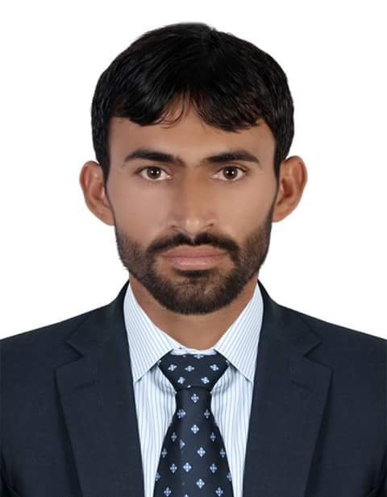

**CAREERS OBJECTIVE**

Looking for an environment to interlard my academic and professional qualifications with my present career milestones which offers a challenging career continuation where

I can exercise my expertise and ability to emerge as one of the best Engineers.

**CAREER OBJECTIVES**

**EDUCATIONAL QUALIFICATION**

* Diploma of Associate Engineer (in Civil).
* Diploma in Quantity Surveying.
* Diploma in Advanced Auto CAD (Civil).
* Secondary School Certificate.
* Higher Secondary School Certificate.

**NAME: - AMANULATEEQ**

**CELL NO: - +971566787658**

**CELL NO: - +971555061865**

**EMAIL ADDRESS: - imateeq90@gmail.com**

**COMPUTER SKILLS**

* Auto-CAD (Expert Level - 2000 to 2018)
* MS Office Excel, Word.

**ASSOCIATED WITH TOPLINK GENERAL CONTRACTING L.L.C AS A LAND SURVEYOR**

PROJECT: - AL FURJAN ROADS STRUCTURE.

CLIENT: - ARIF & BINTOK.

DURATION: - JAN-2015 TO MARCH 2017.

**ASSOCIATED WITH AL QARARAH CONTRUCTION L.L.C AS A Draftsman**

PROJECT: - AL KHAWANEEJ ROAD STRUCTURE.

CLIENT: - ARABTEC ENGINEERING SERVICES.

DURATION: - JAN-2018 TO FEB 2019.

PROJECT: - DISTRICT HEAD QUARTER HOSPITAL PESHAWAR.

CLIENT: - SHAHZ ENGINEERING CONSULTANT.

DURATION: - JUL-2010 TO DEC 2014.

**COMMUNICATION & WORKS DEPARTMENT**

* Preparing Presentation Drawings in AutoCAD.
* Preparing as Built Drawings.
* Preparation of Drawings for Builder's work Layout.
* Preparation of Drawing as per Engineer Instructions.
* Preparation of All types of standard drawing.
* Preparation of Drawing as per Engineer Instructions.
* Preparation of Drawings as per Site Instructions.
* Preparation of Drawings as per Site Clarification Request.
* Training to the new Instructors in Drafting Includes.
* Co-ordination of Builders works with Site Civil and other Service Engineers.
* Preparing Material Submittals.
* Preparation of bill of materials.
* Coordinate with architects, senior engineers, and other engineers.
* Quantity Surveying and Cost Estimation and Site Inspection.
* Collected land survey data using GPS system.
* Operated Trimble GPS, Trimble, Survey Controller.
* Plan and conduct ground surveys designed to establish baselines, elevations, and other geodetic measurements.
* A comprehensive knowledge of ALTA’s, Boundary, and Topographic surveying along with construction staking and GPS experience for land development projects.
* Attained more experience in use of the Leica GPS and Data collector instruments.

**JOB REFFERENCE**

**Visa Status: - Employment**

**Issued Date: - 26/5/2018**

**Dated of Expiry: -**

**26/4/2020**

I hereby declare that all the above furnished details are true to the best of my knowledge and belief.

Date of Birth 2nd Feb 1990.

Marital Status Married

Nationality Pakistani

Languages Known English, Urdu, Arabic

**PERSONAL INFORMANTION**

**DECLARATION**