CURRICULUM VITAE
Vishnu Mohan
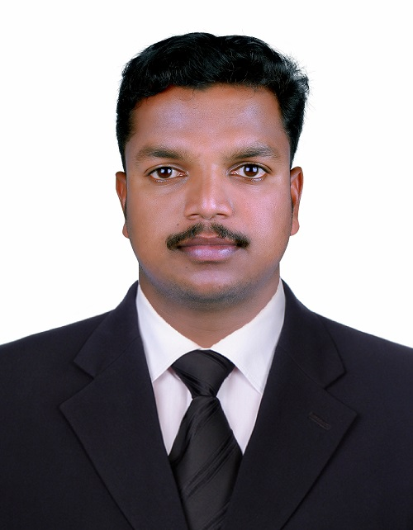
CONTACT Dubai Airport Free zone
Damascus Street
Al Qusais , Dubai

Email : mohan.vishnu200@gmail.com
Tel : +971 565593234
Visa Status : Visit Visa
Valid Up to : 05-March-2019

OBJECTIVE
To assist a prosperous company continues to grow by sharing my practical skills using my 7 years of experience in the Construction industry (Commercial building, Oil and Gas – Onshore & Offshore). Able to work under pressure and courage to take challenging project opportunity where I can contribute my talents to a successful team and to further my knowledge in Civil Engineering Field for development of organization.

SKILLS

- Extensive knowledge of all phases of infrastructure projects and management.
- Ability to work in fast paced environment.
- Good interpersonal and oral communication skills.
- Understanding of cost control implementation and bringing teams together.
- Able to collaborate effectively with construction managers, project managers and engineers.
- Above-average understanding of safety regulations rules and practices.
- Proficient in Word, Excel, Power Point and AutoCAD

PROFFESSIONAL EXPERIENCE

- Year : April 2017 to September 2018
Employer : Copperfield Middle East General Contracting LLC
Position : Civil Supervisor
Project : Field Development project, Package 4 EPC
Consultant : Hyundai Engineering & Construction
PMC / TPI : Jacobs / DNV-GL
Owner : ADNOC - OFFSHORE
- Year : June 2014 to February 2017
Employer : SCON Engineers & Contractors , Ahmedabad, India
Position : Civil Site Supervisor
Projects : Infrastructure, Pipe Pushing Services, Pipeline Construction.
- Year : February 2012 to May 2014
Employer : Al Mukhyzna Trading & Contracting , Haima, Oman
Position : Civil Supervisor
Project : Infrastructure, Pipeline ,Road
Consultant : Wood Group – CCC Ltd.
Owner : PDO – Petroleum Development Oman /
Occidental Petroleum Corporation, Mukhaizna , Oman
- Year : May 2011 to February 2012
Employer : SCON Engineers & Contractors , Ahmedabad, India
Position : Civil Supervisor
Projects : Building

WORK EXPERIENCE - DUTIES AND RESPONSIBILTIES
- Forecasting, selection, training and supervision of man power
Based on the scope of work and project duration.
- Selection of materials of construction based on project specifications from approved vendors.
- Forecasting of plant and equipment required during various stages construction.
- Evaluation of Method statements and ITPs
- Reinforcing, shuttering, pouring and curing of concrete foundations slabs beams etc.
- Special precautions in bulk concreting.
- Erection of equipment and structural members, Grouting.
- Implementing QA/QC feed backs.
- Preparing all civil works permit and safe job plans.
- Conducting Tool Box meeting and LMRA.
- Preparing daily work report and weekly schedules.
- Maintain Safety and Quality as per the project requirements.

ACADEMIC QUALIFICATIONS

- Diploma - (2008 - 2011)
Specialization : Civil Engineering
University : Technical Education Board, Kerala
- Higher secondary - (2006 - 2008)
Specialization : Biology Science
University : Higher Secondary Education Board, Kerala

TRAININGS
- Permit to Work
- H₂S/BA certificate, Confined space
- Initial fire response
- Dealing with Hazards and risks
- HSE Tools and Skills
- Safety Leadership for supervisors
- Hot work safety
- Working at height, Scaffolding

PERSONAL INFORMATION

Date of Birth : 06-Jan-1991
Nationality : Indian
Marital Status : Single
Passport No : J6659524
Date of Issue : 22-Sep-2011
Date of Expiry : 21-Sep-2021

DECLARATION

I hereby declare that the above mentioned details are true to best of my knowledge.

Place : DUBAI VISHNU MOHAN
Date :

