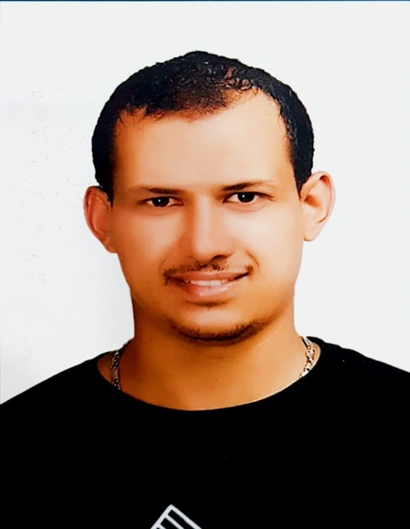

Khaled Esmail Mohamed Darwish
( General Foreman / Supervisor. )

- Personal Information:-

➢ Address: Dirah , Salah Eldin metro station, Dubai, UAE.
➢ Mobile: 0569273054.
➢ Marital Status: single.
➢ Nationality: Egyptian.
➢ E-mail: khaledesmail426@yahoo.com
➢ Date of Birth: 20/08/1989.
➢ Place of Birth: Alexandria, Egypt.
➢ Military Status: Exemption from military service.
➢ Driving License: Egyptian Driving license available till 2023 .

- Education:-

- Qualified above average
Technology college in Quisna , Egypt
High Industrial Technical Institute - Division of Architecture.
Class: 2009.
- Diploma of industrial secondary school: Division of Reinforced Concrete.
Class: 2007.

- Language skills:-

- Arabic: Mother tongue.
- English: Very good command (Speaking - Writing - Reading).

- Computer Skills:-

- Very good command of Microsoft programs and Adobe AutoCAD.

- Work Experience:-

- Trainee at Arab Contractors Co. for Constructions for one year.
- Foreman at Alexandria water Co. ( Egypt 2009 – 2011 ).
- Civil foreman at Dar Al Jouf Engineering Consulting Office supervised the project of water networks in the residential area in Land port Al-Haditha and Al-Qurayyat (Saudi Arabia In the period from 2011 – 2013 ).
- Civil foreman at Al - Arini Contracting Co. in the following projects:
1 - Housing Project , Mosques and Ground water tanks in Sakaka City, Saudi Arabia ( 2013 – 2015 ).
2 - The project of Constructing and developing the Roqaie land port - Eastern Province, Saudi Arabia ( 2015 – 2016 )
- Civil foreman at Al - Gharabli Co. For Integrated Engineering Works in the following projects:
1 - The project of Construction of Sidi Gaber bridge and Mostafa Kamel underground garage in Alexandria, Egypt. ( 20/10/2016 – 30/03/2017 ).
2 - Construction of the Ministry of Defense building ( Number 101 ) in the new administrative capital, Egypt ( 1/04/2017 – 20/09/2017 )
- General foreman at Advanced business company for contracting in Saudi Arabia in the project of Constructing of The primary school in Al Aziziyah area in Medina ( 1/10/2017 – 30/8/2018 ).

- Professional Skills:-

- I am a member of the Saudi organization of engineers - General supervisor.
- I have an excellent experience at :
- Surveying works.
- Infrastructure works.
- Concrete testing and sampling.
- References:-
Available upon request.

